**The Rising of the Shield Hero Season 2: Release Date and other details!** 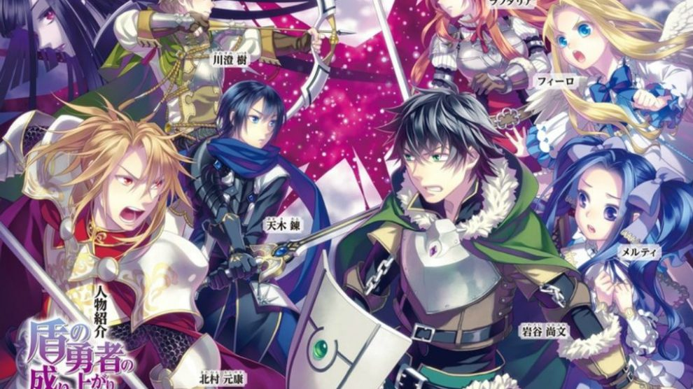

***The Rising of the Shield Hero***, a Japanese anime of dark fantasy genre grounded on the light novel series written by Aneko Yusagi and published by Shosetsuka ni Naro. The Light novel was illustrated by Minami Seira and published by **Media Factory**. These light novel series got published from 2012 to 2015. Then the series was adapted into a manga series by Aiya Kyu and published by the Light novel publisher, Media Factory. It was first published on February 5, 2014, and till November 21, 2020, the 17th volume of the series has been released by Media Factory.

**The Rising of the Shield Hero Season 2: Release Date**

An anime adaption of the series was announced way back in June 2017. The *anime series* is produced by Kinema Citrus and directed by Takao Abo. The Rising of the Shield Hero Season 1 premiered from January 9 to June 26, 2019, on AT-X and other channels. *Season* 1 comprised of 25 episodes. Crunchyroll announced in 2019 at its Expo, that the series will be **renewed** for a **second** and third ***season***. Then again at 2020s Crunchyroll Expo held virtually it was announced that the series will begin its ***season 2*** premiere in 2021. Junichiro Tamura announced that the wait between ***season 2*** and season 3 will not be as long as between the first two seasons.

**The Rising of the Shield Hero Season 2: Expected Plot and cast**

Before delving deep into the storyline of Season 2. Let's recap in brief what happened in Season 1. *Naofumi Iwatani*, a Japanese youth who's called in a parallel universe along with other 3 teenage men of some other parallel universe to fight with demons named Waves and become World's leading Heroes. Naofumi receives the ancient heroic powerful shield, protective gadget while the other heroes receive a sword, a spear, and a bow i.e., striking gadget. Naofumi copes up with many hardships, unlike the other three men who're privileged because of them being born to wealthy and known people. Naofumi's ally kingdom's princess cheats on him by stealing all his belongings and falsely accuses him of assaulting her sexually. 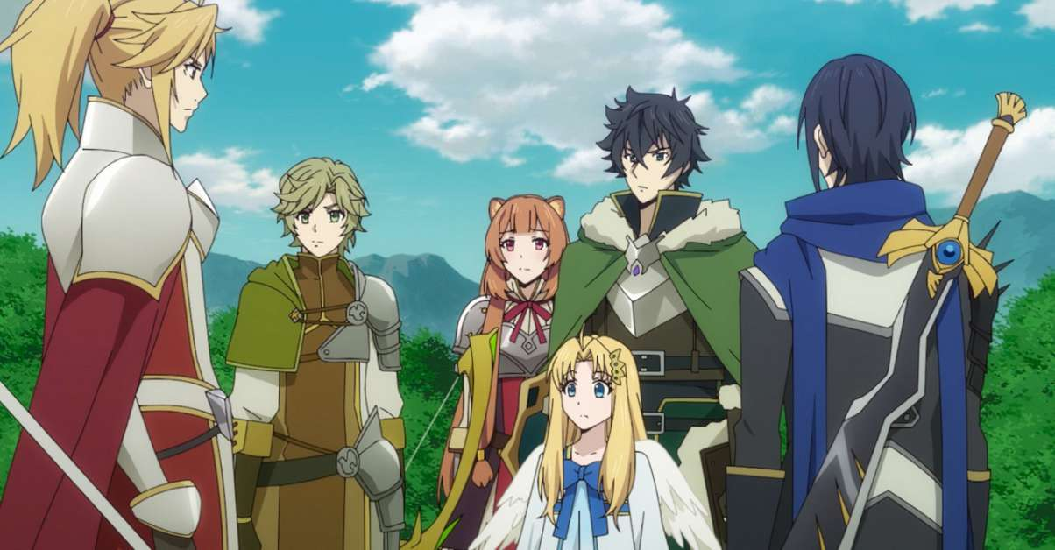

Since he's left out by everyone and feels to be assaulted by his mates, he trains himself as the hero alone, until he gets a companion in the form of a bird-like demon whom he names "Filo" and both of them grew together and become very mighty fighters. That bird-like demon named "Filo" is gifted to Naofumi by a young tanuki demi-human girl named Raphtalia. She gifts Filo as an egg. And then slowly Naofumi is shown to gain the trust of his fellow companions and they work together to unveil the mysteries behind Waves which are a danger to everyone.

So, by the end of Season 1, it's revealed that heroes from another parallel universe will be joining Naofumi and his companions to give tough competitions. So, it's likely that in ***Season 2*** Naofumi has to hone his fighting skills more and more to combat them. Additionally, Season 2 will take us back to the secret of the book which Naofumi got to know before transported to another world. We'll be meeting the king in a courtroom involving an immense storyline with this character as well. So, ***Season 2*** is likely to revolve around the adventurous journey of Naofumi, the hard training of Naofumi to hone his skills, and reviving the memories from the past.

**The Rising of the Shield Hero Season 2: Trailer**

***The Rising of the Shield Hero Season 2 traile***r has been streamed, so you can relish them until the episodes are premiered 😊

https://www.youtube.com/watch?v=1pRMe67pR94